16/11/21
THM 415: Finance
Midterm Exam Answer Sheet

- “In General Partnership, all partners jointly share unlimited liability”. Do you agree with this statement? Why? Why not? (2 Points)
Yes, I agree with this statement. In fact, since general partnership is composed only of general partners, who by definition, take active role as decision makers in the company, they are indeed not only responsible for the company’s debt (no limit to this amount) but also if some general partners fail to pay their part of the debt, all the debt is still paid by the remaining general partners (i.e. joint liability).
- Miralem Hotel had recorded the following income statement accounts sorted in alphabetical order:
Cost of Goods Sold | $4,216,758
Interest Expenses | $564,921
Operating Expenses | $1,545,777
Sales | $8,043,250

In addition, since Miralem Hotel owns 42 % shares of Pjanic Company, it is entitled to $ 1,903,903 of dividends income from that very company. Moreover, Miralem hotel’s board of directors decided to distribute $ 575,750 as dividends to their shareholders.
The following table reveals Income Tax Rates for Corporate Income for 2020 fiscal year:

Taxable Income | Marginal Tax Rate
$ 0 – $ 200,000 | 8%
$ 200,001 - $300,000 | 10%
$ 300,001 - $ 500,000 | 12%
$ 500,001 - $ 750,000 | 14%
$ 750,001 - $ 1,000,000 | 16%
$ 1,000,001 - $ 1,400,000 | 18%
Over $ 1,400,000 | 20%

Lastly, the following table shows dividend income exclusion to avoid double taxation at corporate level.
Ownership Interest | Dividend Exclusion
Less than 15 % | 20%
15 % to 30 % | 40%
30 % to 45 % | 60%
45 % to 62 % | 72%
62 % to 80 % | 83%
More than 80 % | 100%

a) Construct Miralem Hotel Income Statement for the year ended December 31st, 2020. (2 Points)

Moreover, the following is Miralem Hotel’s comparative balance sheet as of December 31st, 2019 and December 31st, 2020:

- Construct Miralem Hotel Statement of Cash Flow for the year ended December 31st, 2020. (3 Points)
- Calculate the Quality of Earnings. Interpret your result. (1 Point)
- Quality of Earnings = (Cash Flow from Operations) / (Net Income) = 1,023,806 / 1,303,323 = 78.55 %.
Thus, in 2020, Miralem Hotel’s cash flow from operations was 78.55 % of the firm’s reported net income.
- Calculate the Capital Acquisition Ratio. Interpret your result. (1 Point)
- Capital Acquisition Ratio = (Cash Flow from Operations) / (Cash Paid for Capital Expenditures) = 1,023,806 / 28,294 = 3,618.46 %.
Thus, in 2020, Miralem Hotel was able to finance 3,618.46 % of its new expenditures for plant and equipment out of the firm’s operation’s cash flow.
- Based on the income statement prepared in part a), comparative balance sheet and cash flow statement prepared in part b), analyze the financial situation of Miralem Hotel for the fiscal year 2020. (3 Points)
Income Statement:
- In 2020, Miralem hotel is a profitable company as its revenues (i.e. sales) are greater than its costs.
- In 2020, Miralem Hotel’s mark-up on its cost of goods sold is 47.57 %.
- In 2020, for each dollar of revenue, Miralem Hotel is left with 28.36 cents after deducting all its operating expenses.
- In 2020, each one dollar of sales is associated with 16.20 cents of net income.
Balance Sheet:
- Miralem hotel is a highly liquid company as its net working capital is $ 2,176,383. This means that current assets can shrink by as much as $ 2,176,383 and the company would still be able to pay its current liabilities.
- In Miralem Hotel, the purchases of assets are financed 37.28 % through debt and 62.72 % through equity.
- For each one dollar of net income, 55.82 cents are retained in the business.
Statement of Cash Flow:
Cash flow from operating activities:
- Miralem Hotel has positive cash flows from operating activities.
- The primary contributor to the operating cash flows was net income.
- Accounts receivables, inventories, other current assets, and accounts payable constitute cash usage.
Cash flow from investing activities:
- Miralem Hotel invested $ 28,294 in purchasing fixed assets. This is roughly 2.76 % of the total cash flow generated from operations.
Cash flow from financing activities:
- Miralem Hotel has negative cash flows from financing activities.
- All cash outflow went as payment of already declared dividends, purchase of marketable securities and payment for long-term notes.
- The contributors to cash inflow were short-term notes, issuance of common stock and common stock (par value).
- Suppose you would like to quadruple your investment. For this purpose, you deposited in a bank $ 18,004.59 to be compounded monthly at an interest rate of 9.03 %. Calculate the period (in years) needed to reach your objective? (1 Point)
- Interest Rate = 9.03 % / 12 = 0.7525%; Present Value = - $ 18,004.59; Payment = $0; Future Value = $ 72,018.36.
Answer: Nper (0.7525%, 0, -18004.59, 72018.36) / 12 = 15.41 Years.
Therefore, it would take 15.41 years for an investment of $ 18,004.59 to quadruple at an annual interest rate of 9.03 % compounded monthly.
- After examining the various interest rates opportunities, you find that you can borrow from a finance company at 20.01 % compounded weekly, from bank A at 20.47 % compounded quarterly.
a) Which alternative is the most attractive? Why? (1 Point)
- Borrowing from Finance Company: Effective Annual Rate = Effect (20.01 %, 52) = 22.10 %.
- Borrowing from bank A: Effective Annual Rate = Effect (20.47 %, 4) = 22.10 %.
→ Since I am borrowing, I shall choose the offer that has the lowest Effective Annual Rate. Therefore, I shall borrow from bank A (22.0956 % vs. 22.1056 %).
b) If you wanted to consider Bank B which offers continuous compounding. What is the maximum interest rate suggested by this very bank to start thinking about the offer? (1 Point)
The maximum interest rate suggested by Bank B shall be 19.96 %.
- Teixeira wanted to buy a home that costs $ 400,000. He took a 10-year mortgage loan with semi-annual payments at an annual rate of 5.25 %.
a) How much will Teixeira pay each period? (1 Point)
Interest = 5.25 % / 2 = 2.625 %, Period = 10 * 2 = 20; Present Value = $ 400,000; Future Value = $ 0
Answer: PMT (2.625 %, 20, 400000, 0) = - $ 25,962.80.
b) Fill in the amortization schedule. (3 Points)
Period | Amount Owed on the Principal (Beg. Period) ($) | Annuity Payment ($) | Interest Portion of the Annuity ($) | Repayment of the Principal Portion of the Annuity ($) | Outstanding Loan Balance ($)
1 | 400,000.00 | 25,962.80 | 10,500.00 | 15,462.80 | 384,537.20
2 | 384,537.20 | 25,962.80 | 10,094.10 | 15,868.70 | 368,668.50
3 | 368,668.50 | 25,962.80 | 9,677.55 | 16,285.25 | 352,383.25
4 | 352,383.25 | 25,962.80 | 9,250.06 | 16,712.74 | 335,670.51
5 | 335,670.51 | 25,962.80 | 8,811.35 | 17,151.45 | 318,519.07
6 | 318,519.07 | 25,962.80 | 8,361.13 | 17,601.67 | 300,917.39
7 | 300,917.39 | 25,962.80 | 7,899.08 | 18,063.72 | 282,853.68
8 | 282,853.68 | 25,962.80 | 7,424.91 | 18,537.89 | 264,315.79
9 | 264,315.79 | 25,962.80 | 6,938.29 | 19,024.51 | 245,291.28
10 | 245,291.28 | 25,962.80 | 6,438.90 | 19,523.90 | 225,767.37
11 | 225,767.37 | 25,962.80 | 5,926.39 | 20,036.41 | 205,730.97
12 | 205,730.97 | 25,962.80 | 5,400.44 | 20,562.36 | 185,168.61
13 | 185,168.61 | 25,962.80 | 4,860.68 | 21,102.12 | 164,066.49
14 | 164,066.49 | 25,962.80 | 4,306.75 | 21,656.05 | 142,410.43
15 | 142,410.43 | 25,962.80 | 3,738.27 | 22,224.52 | 120,185.91
16 | 120,185.91 | 25,962.80 | 3,154.88 | 22,807.92 | 97,377.99
17 | 97,377.99 | 25,962.80 | 2,556.17 | 23,406.63 | 73,971.36
18 | 73,971.36 | 25,962.80 | 1,941.75 | 24,021.05 | 49,950.31
19 | 49,950.31 | 25,962.80 | 1,311.20 | 24,651.60 | 25,298.71
20 | 25,298.71 | 25,962.80 | 664.09 | 25,298.71 | 0.00
c) Suppose that exactly after 3 years, mortgage interest rates fell to 4.55 %. If Teixeira has the chance to refinance his loan, at that very interest, how much would he pay (on a semi-annual basis) for the remaining 3 years of the loan? (1 Point)
Interest = 4.55 % / 2 = 2.275 %, Period = 7 * 2 = 14; Present Value = $ 300,917.39; Future Value = $ 0
Answer: PMT (2.275 %, 14, 300917.39, 0) = - $ 25,339.98.
d) If such a refinance opportunity is associated with paying a prepayment penalty fee to the bank of $ 6,750, shall Teixeira refinance his loan? Why? Why not? (2 Points)
The answer to this question lies in coming up with cash flow increments by taking the difference of cash flows (for each of the remaining 7 years) between the first scenario (i.e. continuing paying $ 25,962.80) and second scenario (i.e. paying $ 6,750 as a penalty in year 0, and saving $ 622.82 for the remaining 14 six-month periods). To sum up, the following table reveals the cash flow increments from opting for the second scenario:
As can be seen from the above table, paying $ 6,750 as a pre-payment penalty but start saving $ 622.82 for the remaining 14 six-month periods (i.e. 25,962.80 – 25,339.98) would yield a positive return. Hence, Teixeira shall re-finance the mortgage loan since he will be better off in the second scenario.
- Upon evaluation of the distribution of returns of Batshuayi company, the following possible rate of returns for the upcoming period as long as their probability of occurrence are estimated:
Probability of Occurrence | Rate of Return on Investment
11% | -7.14%
10% | -5.53%
12% | -3.14%
15% | 3.54%
18% | 4.87%
20% | 7.62%
14% | 9.53%
a) Calculate the Expected Rate of Return of Batshuayi Company stock. (1 Point)
- Expected Rate of Return = (11 % * - 7.14 %) + (10 % * - 5.53 %) + (12 % * - 3.14 %) + (15 % * 3.54 %) + (18 % * 4.87 %) + (20 % * 7.62 %) + (14 % * 9.53 %) = 2.55 %.
b) What is the risk of the investment in Batshuayi Company stock as measured using the standard deviation of possible future rates of return? (2 Points)

- Kenan bought some stocks of Karaman Company worth of 1,000,000 Euros 8 years ago. Following is the beginning value of Karaman bought stocks 8 years ago as well as the values at the end of each year up until today (the end of year 8):
Year | Annual Rate of Return | Stock Value (Euros)
0 |  | 1,000,000.00
1 | -4.58% | 954,200.00
2 | -3.65% | 919,371.70
3 | 5.41% | 969,109.71
4 | 6.83% | 1,035,299.90
5 | 3.19% | 1,068,325.97
6 | 8.53% | 1,159,454.17
7 | 7.96% | 1,251,746.73
8 | -3.04% | 1,213,693.63
a) What will be the annual rate of return that Kenan expects to earn next year, if he plans to continue holding Karaman Company stocks? (1 Point)
- Annual rate of return that Kenan expects to earn next year, if he plans to continue holding Karaman Company stocks = (- 4.58 % - 3.65 % + 5.41 % + 6.83 % + 3.19 % + 8.53 % + 7.96 % - 3.04 %) / 8 = 2.58 %.
b) What annual rate of return that Kenan expects over a four-year horizon from holding Karaman Company stocks? (1 Point)
- Annual rate of return that Kenan expects over a four-year horizon from holding Karaman Company stocks = ((1 + 3.19%) * (1 + 8.53%) * (1 + 7.96%) * (1 - 3.04%))^^{(1/4)} – 1 = 4.05%.

- You own a portfolio consisting of the following stocks:

Stock | Portfolio Allocation | Beta | Expected Return
1 | 16.00% | 0.73 | 13.25%
2 | 22.00% | 1.53 | 22.12%
3 | 19.00% | 1.28 | 18.89%
4 | 20.00% | 0.45 | 10.03%
5 | 23.00% | 1.16 | 16.99%

Assume the risk-free rate is 4.85 % and the expected return on the market portfolio is 16.03 %.
- Calculate the expected return of your portfolio. (0.50 Points)
- Expected return (Portfolio) = (16 % * 13.25 %) + (22 % * 22.12 %) + (19 % * 18.89 %) + (20 % * 10.03 %) + (23 % * 16.99 %) = 16.49 %.
- Calculate the portfolio beta. (0.50 Points)
- Beta (Portfolio) = (16 % * 0.73) + (22 % * 1.53) + (19 % * 1.28) + (20 % * 0.45) + (23 % * 1.16) = 1.05.
- Plot the security market line on a graph. (2 Points)

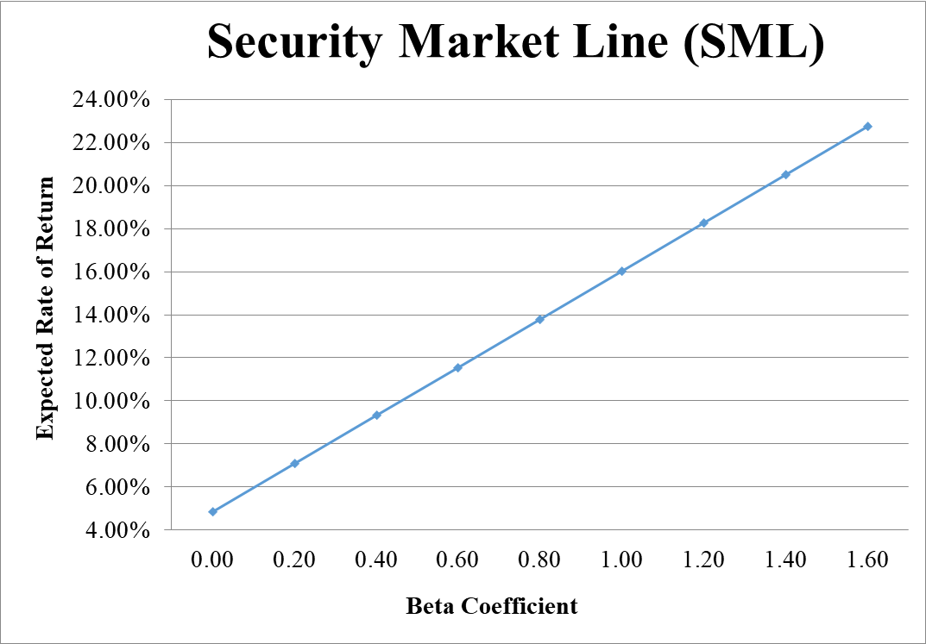
- From your plot in part c, which stocks appear to be your winners, and which ones appear to be losers? Explain the reason behind your conclusion. (2 Points)
- Why should you consider your conclusion in part d) to be less than certain? (1 Point)
This conclusion is based on our having the right betas. Recall that calculation of Betas are subjective (i.e. depend on the market to be chosen, sample size, time interval chosen, definition of period…). If all of our betas understate their stock’s systematic risks, then we would be underestimating our portfolio risk.
GOOD LUCK!

